Common Performance Tunning Setting in JBOSS Environment

Although many architects and software engineer agree that about 70-80% of the application performance depends on how the application itself is coded—a poorly configured server environment can affect your user experience significantly, and eventually, on your application value.
The amount of configuration elements, which can influence your server performance are quite a lot;

1.) Setting the Correct Java Version(installing the Correct java version before installing the JBOSS Server Software in a Machine

Java developer—JBOSS----Runs in a Development Mode(JDK)

Server Admin—JBOSS—Runs in Production Mode(JRE)

JDK 1.5 or JRE 1.5 -----JBOSS 5.1=Booted Running
JDK 1.6 or JRE 1.6 -----JBOSS 6.1=Booted Running

JDK 1.6 or JRE1.6 -----JBOSS 7=Booted Running

Java 11 | Java 11
JBoss 7.4 | JBOSS 7.4
Client Application---Java 11 | CurrentApp--Java 11  New Release-Java 12

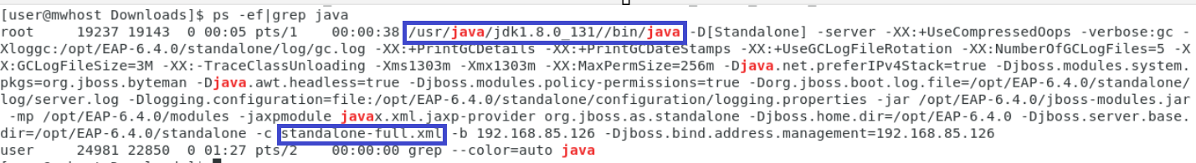

To change the version of java, as below
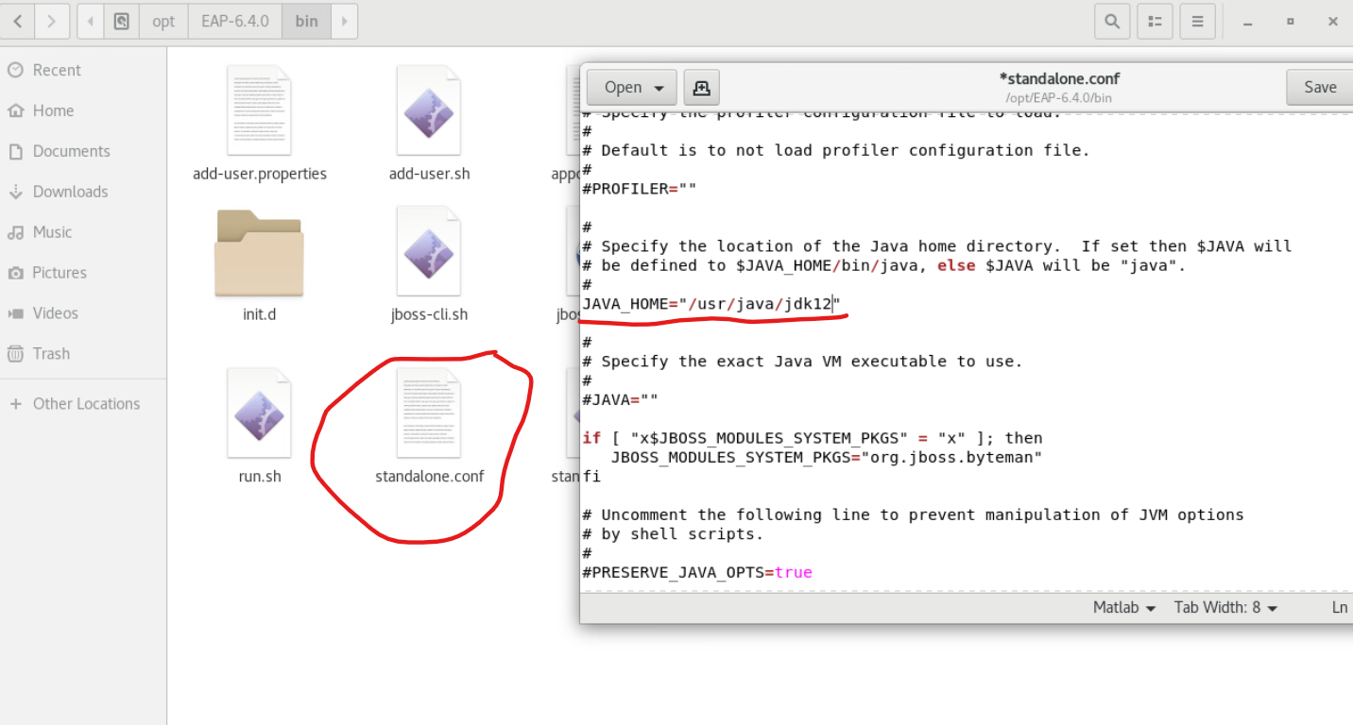

2.JVM Tunning Memory Maintenance

The JBoss AS 7 runs within a Java Virtual Machine (JVM), hence it's natural that the AS can give a better performance with proper configuration of the JVM parameters.
JVM tuning has evolved over the years and actually changed with each version of Java. Since the release 5.0 of the J2SE, the JVM is able to provide some default configuration ("Ergonomics") which is consistent with your environment. However, the smarter choice provided by Ergonomics is not always the optimal and without an explicit user setting, the performance can fall below your expectations.
Basically, the JVM tuning process can be divided into the following steps:
• Choose a correct JVM heap size. This can be divided into setting an appropriate initial heap size (-Xms) and a maximum heap size (-Xmx).
• Choose a correct Garbage collector algorithm.

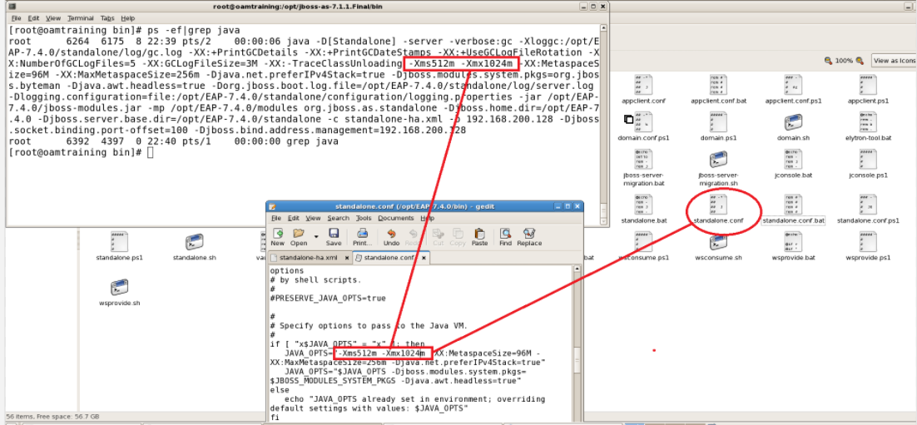

Try to maintain the free memory equal to the used memory

Only by running the Garbage Collector in a scheduled manner

0 ms to 5 seconds------ 2000ms

Example:

1 JBOSS= 2048MB on total JVM Memory

In runtime as admin you have to maintain 1024MB is occupied(used memory) out of 2048

Remaining 1024MB should be free

Occupied 1024MB JVM memory= 200 Req/sec 100 transaction/Minute

Free 1024 MB= 500 Req/sec 200 Transaction/Minute

run.gc()
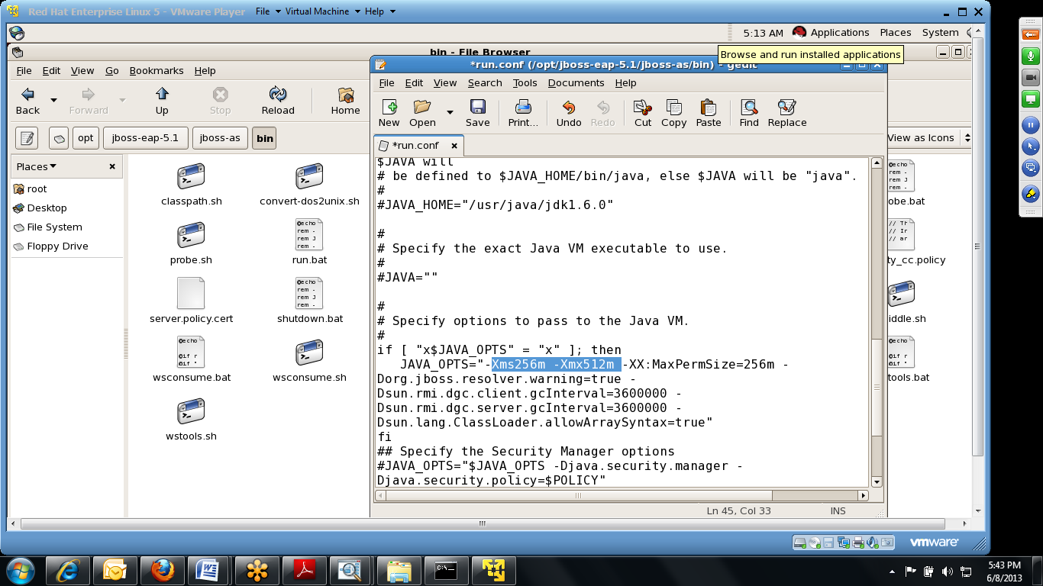

New Generation is further divided into three parts known as Eden space, Survivor 1, and Survivor 2 space. When an object is first created in heap, it gets created in new generation inside Eden space, and after a subsequent minor Garbage collection if the object survives, it gets moved to survivor 1, and then to Survivor 2 before the major garbage collection moved that object to Old or Tenured generation.
Permanent generation of Heap or Perm Area of Heap is somewhat special and it is used to store meta data related to the classes and methods in JVM; it also hosts String pool provided by JVM.
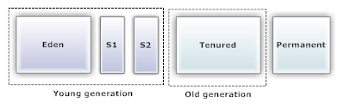
In order to tune the JVM, you should choose a correct ratio between young generation (where objects are initially placed after instantiation) and the tenured generation (where old living generations are moved).
For most applications, the correct ratio between the young generation and the tenured generation ranges between 1/3 and close to 1/2.
The appropriate max heap size can be determined by testing your application with a peak load for a consistent time. Once you have determined the peak of memory demanded by your application, you can allow an extra 25-40% additional maximum heap size, depending on the nature of your application.
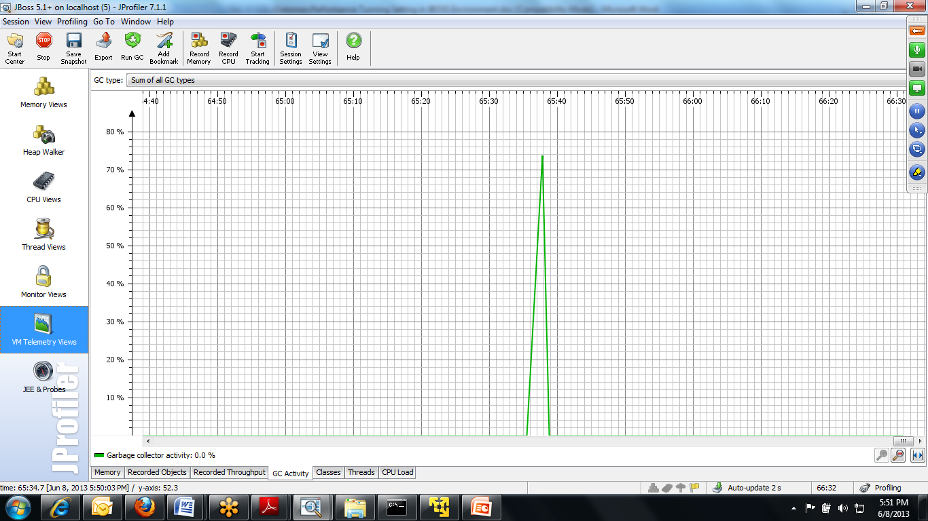

Garbage Collection
Garbage collection is a mechanism provided by Java Virtual Machine to reclaim heap space from objects, which are eligible for Garbage collection
Serial collector (-XX:+UseSerialGC): It performs garbage collector using a single thread which stops other JVM threads. This collector is fit for smaller applications; we don't advice using it for Enterprise applications.
• Parallel collector (-XX:+UseParallelGC): It performs minor collections in parallel and because J2SE 5.0 can also perform major collections in parallel (-XX:+UseParallelOldGC). This collector is fit for multiprocessor machines and applications requiring high throughput. It is also a suggested choice for applications which produces a fragmented Java heap, allocating large-size objects at different timelines.
• Concurrent collector (-XX:+UseConcMarkSweepGC): It performs most of its work concurrently using a single garbage collector thread that runs with the application threads simultaneously. It is fit for fast processor machines and applications with a strict service-level agreement. It can be the best choice, also for applications using a large set of long-lived objects live HttpSessions.

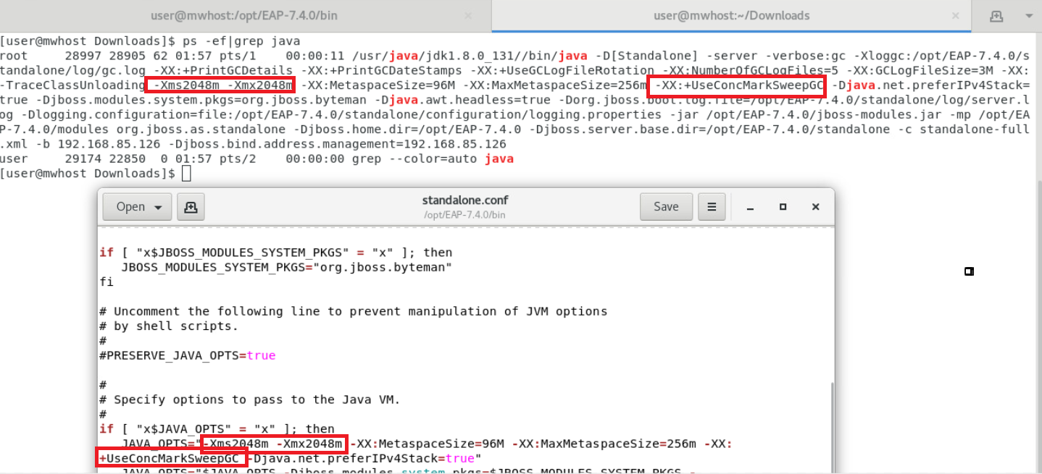

3.Default values in JBOSS

One Application Server =Thread Count= 65536/Sec

JBoss AS uses several resource pools to manage different kind of services. The application server ships with a default configuration for all resource pools which could be just good for simple applications. If you are planning to write mission-critical applications, however, you need to find the appropriate number of resources to be assigned to your pools.
We will discuss in particular on the following pool of resources, which ultimately play an important role on performance tuning:
• The database connection pool

4.Equalizing the JDBC Connection Pool Capacity

Setting the Minimum Connections=Maximum Connections
<min-pool-size>10</min-pool-size>
<max-pool-size>30</max-pool-size>
<timeout>
<blocking-timeout-millis>30000</blocking-timeout-millis>
<idle-timeout-minutes>5</idle-timeout-minutes>
</timeout>

